Created a **Gradle project** there added Gadle environment needed code.

After that **product.java** class created and added variables and written the code for variable.

In final created **productTransfer.java** for functions to write.

**Compilation was done in Ternimal** .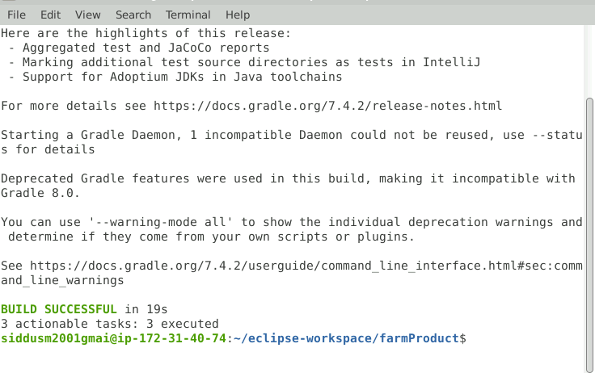

**Navigated the Jar file and Renamed it by farmproduct-1.0.jar**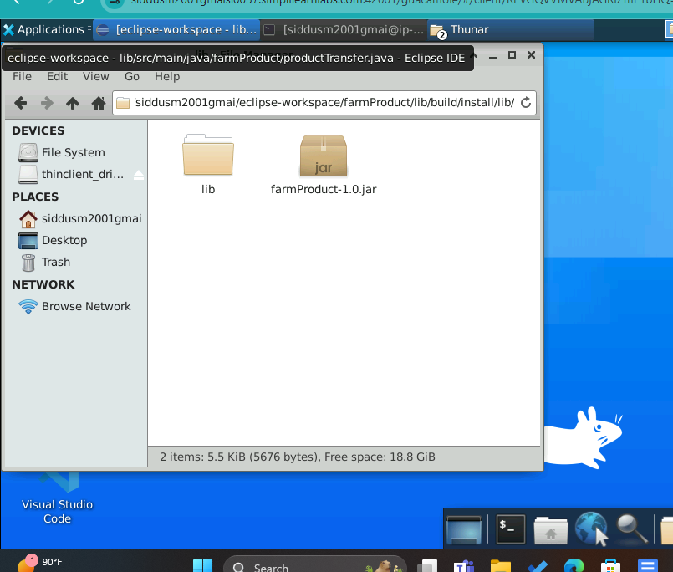

**Started the test network by executing the command: *sudo ./network.sh up -ca -s couchdb***

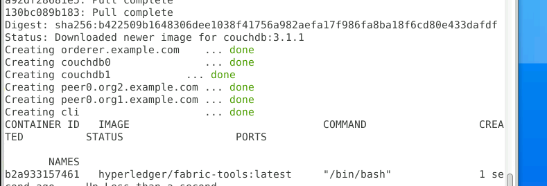

**created a communication channel for the peers in the test network.**

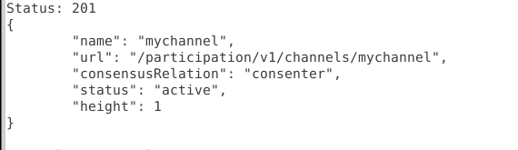

**list the newly created farmProduct.tar.gz package:**

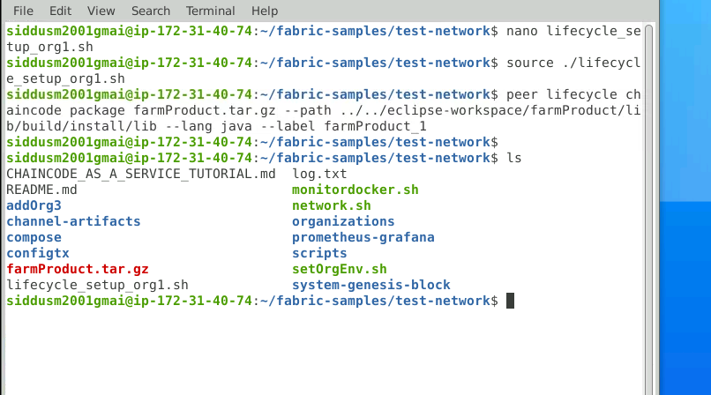

**Installation of chain code on both peers was done.** 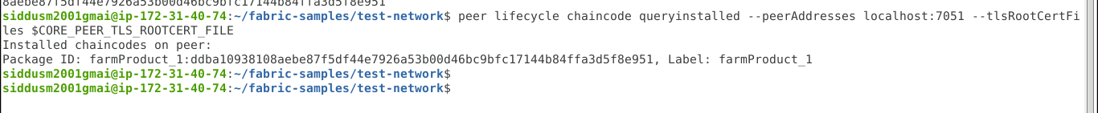

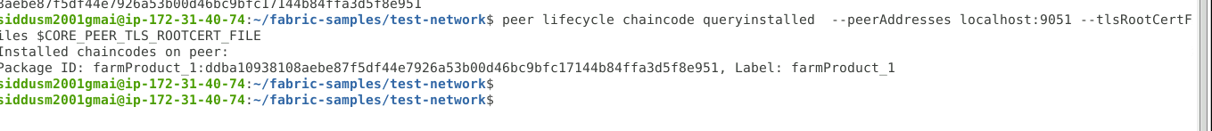

**Project OutPut:**

**1.Add a new farm product asset to the ledger**

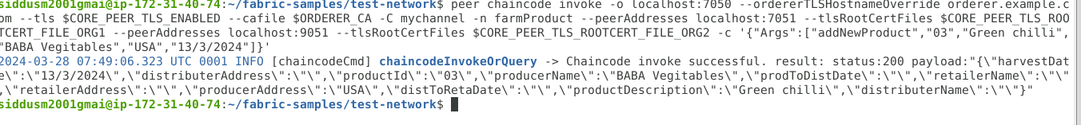

**2.Transfer the ownership of farm product asset to distributer**



**3.Transfer the farm product from distributer to Retailer:**



**4.farm product complete cycle.**



